GSTIN: 09AAACU4749D2Z9 OFFICE OF THE
EXECUTIVE ENGINEER
CENTRAL PURCHASE DIVISION-I

PARICHHA THERMAL POWER PROJECT
UTTAR PRADESH RAJYA VIDYUT UTPADAN NIGAM LIMITED
(UPGOVT UNDERTAKING)
PO PARICHHA, JHANSI-284305
(UTTAR PRADESH) Fax: 0510-2782192
E-mail: eecpd12012@gmail.com

No.33/CPD-I/PTPP/O-I Date: 10.04.2018

AMENDMENT

Following amendment is hereby made in following Purchase Order no. 1810/CPD-I/PTPP/O-1/EPED-I dated 30.10.2015 w.r.t approval from PTC, PTPP on dated 10.04.18 for PO amendment placed on M/s. Ashbond Engineers Private Limited, B-9/3, Mainwali Nagar, Rohtak Road, New Delhi-110087, with respect to their e-mail dated 09.04.18 for amendment as follows:

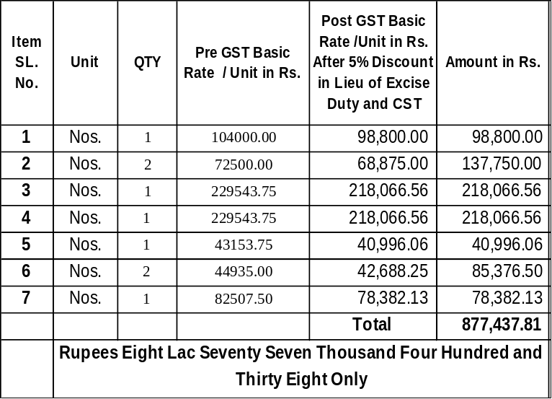

Freight- Nil
Packing & Forwarding Charges: NIL
GST Extra as applicable on Basic as per HSN Code at the time of supply.
Anti Profiteering Clause: “As per section 171 of CGST Act 2017, any reduction in rate of tax on any supply of goods or services or the benefit of input tax credit shall be passed on to the recipient by way of commensurate reduction in prices. Hence supplier/ manufacturer to ensure to pass the benefit of reduced prices to UPRVUNL. Further price quoted by supplier/ manufacturer is subject to scrutiny under above section”.
All other Terms & conditions shall remain unchanged.
(Dilip Kumar Jain)
EXECUTIVE ENGINEER

No.33/CPD-I/PTPP/O-I Date: 10.04.2018 Copy forwarded to the following for information and necessary action:
  - Superintending Engineer, O & MC-IV, C&IEC, PTPP, Parichha (Jhansi)
  - Dy. CA.O. (Accounts), PTPP, Parichha (Jhansi).
  - Executive Engineer, Central Store Division-II, PTPP, Parichha (Jhansi) (In three copies )
  - Executive Engineer, EPED-I, with reference to Req. no. 78/EPED-I/PTPP/R-I, dated 16.03.2015 for O/H#6, 2X250 MW
  - AE-I,CPD-I, PTPP, Parichha.
  - Case file of enquiry no. 501/CPD-I/ PTPP/CF, date 31.03.2015.
  - M/s Ashbond Engineers Private Limited, B-9/3, Mainwali Nagar, Rohtak Road, New Delhi-110087.

(Dilip Kumar Jain))
EXECUTIVE ENGINEER

